**Screenshots Of Virtual Key For Your Repositories:-**

**GitHub Reciprocity Link**:- <https://github.com/kapildavey/Phase1.git>

**RETRIEVEING FILES IN ASCENDING ORDER:-**

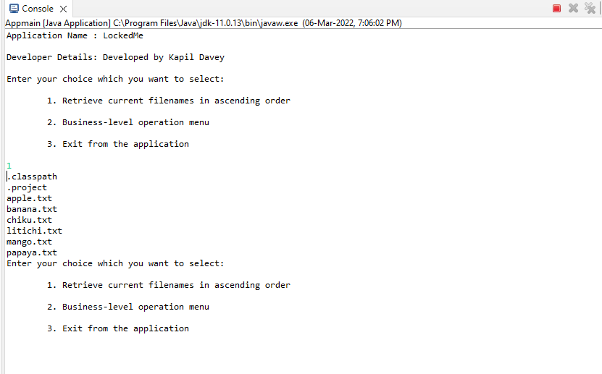

**ADDING FILES:-**

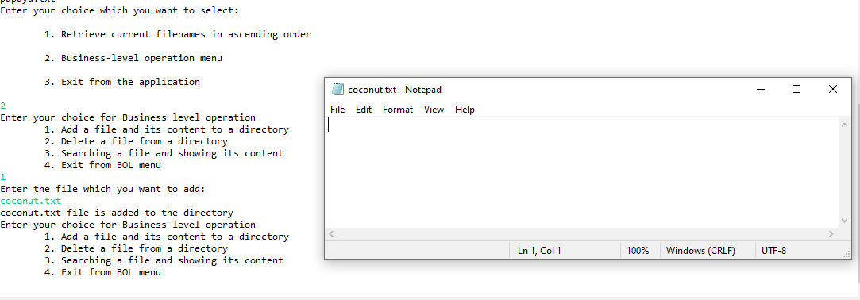

**DELETING FILES:-**

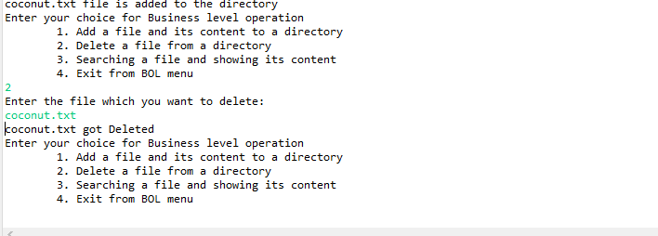

**SEARCHINF FILES:-**

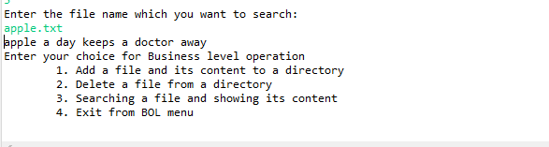

**EXIT FROM APPLICATION:-**

